SYSC 5104
METHODOLOGIES FOR DISCRETE EVENT

MODELING AND SIMULATION

Consumers’ Choice Cell-DEVS Model Simulation
(Assignment 2)

Liu, Qi
Student Number: 100668855
E-mail: liuqi@sce.carleton.ca

Carleton University

Contents
Part I Conceptual Model Description 3
Part II Formal Specifications and Test Strategies 4
Formal specifications for the Cell-DEVS model ..4
Testing strategies 5
Part III Simulation Results and Analysis 6
Mature Market Dynamics Simulation Results and Analysis 6
New Market Dynamics Simulation Results and Analysis 8
Notes and References 11
Appendix 12

Part I Conceptual Model Description ^{[1]}
In today’s society, consumers choose among competing information products in a rapidly changing market. These purchasing decisions are made not only based on their own preferences but also under the influence of others. There are basically three factors that contribute to consumers’ purchasing behavior: the utility obtained by using a particular information product, the effect of network externality, and the price of the products ^{[2]}. A cellular automata model (Consumers’ Choice) is constructed to simulate the dynamics of two types of markets consisting of consumers with relatively homogeneous needs and wants.

In this model, N² consumers are represented by a N×N cell space. Each cell stands for an individual consumer who will choose from two rivaling Operating System (OS) providers. They will make a new or renewal contract with one of these providers at the beginning of every week. Each cell has three possible states, i.e. non-user, user of OS1, user of OS2, which are denoted as 0, 1, and 2 respectively. We designate binary variable X(c_{ij}, n, t) = 1 (n = 1 or 2) if the cell c_{ij} represents a user of OS_{n} at time t, and X(c_{ij}, n, t) = 0 if the cell c_{ij} represents a non-user of OS_{n} at time t. We assume that X(c_{ij}, n, t) and X(c_{ij}, 3-n, t) cannot be 1 at the same time for each cell, that is, no consumer can sign contracts with both providers simultaneously. Three contributing factors are calculated by three functions ^{[3]}:
- Utility function:
U(c_{ij}, n, t) = U_{min} + θ(U_{max} - U_{min})L(c_{ij}, n, t) (1)
where U_{min} stands for the basic utility that a beginner of an OS can readily obtain through using the system, while U_{max} is the maximal utility that a user can get within a time cycle. L(c_{ij}, n, t) =λ( X(c_{ij}, n, t-1) AND X(c_{ij}, n, t) ) stands for the skills for using OS_{n} that a consumer acquires at the current time cycle, which could be passed on to the next cycle if the consumer chooses to use the same system. λ is a given constant between 0 and 1 representing the speed of skill depreciation. θ(U_{max} - U_{min}) is the weight for the effect of consumers’ learning by doing. The utility function value for a non-user is 0.

2. Network externality function:
E(c_{ij}, n, t) = (1 - θ) (U_{max} - U_{min})N(c_{ij}, n, t-1) (2)
where N(c_{ij}, n, t-1)=∑_{neighborhood} X(c_{neighborhood}, n, t-1) /η, η is the number of neighbors for a cell. For each cell, the value of the network externality function for a particular OS at time step t is calculated based on the percentage of users of that OS at previous time step (t-1) within the cell’s neighborhood. (1 - θ) (U_{max} - U_{min}) is the weight for the effect of consumers’ network externality. The value of this function for a non-user is 0.

3. Pricing function:
P(c_{ij}, n, t) = ( X(c_{ij}, n, t) + X(c_{ij}, 3-n, t) )P_{OSn} n = 1 or 2 (3)
where P_{OSn} is the price for the operating systems. This price is calculated as P_{OSn} (c_{ij}, n, t)= Q(n, t) + R(m, n, t), in which Q(n, t) is a given constant representing the global price for a system that is a portion of the whole price, and R(m, n, t) is a variable representing the local price for a system that fluctuates according to the local market condition for each consumer. In order to maintain a balance between maximal profit and market shall, a provider may reduce local prices to attract more consumers when it loses market share to rivals, and then raise local prices to gain more profit when its market share is bigger than competitors. The local price is calculated as R(m, n, t)=Rn_{min}+ μ(Rn_{max} - Rn_{min})( N(c_{ij}, n, t-1)- N(c_{ij}, 3-n, t-1) ), where Rn_{max} and Rn_{min} are the maximum and minimum local price for a system and μ is coefficient for the amplitude of the fluctuation. The price for a non-user is 0.

At each time step, consumers calculate the expected value gained by using one of the two systems or using none of them by V(c_{ij}, n, t) = U(c_{ij}, n, t) + E(c_{ij}, n, t) - P(c_{ij}, n, t) for all the three possible state changes, and choose the state with the maximal V(c_{ij}, n, t) value. If the consumer chooses to be a non-user, the expected value is 0.

Part II Formal Specifications and Testing Strategies

Formal specifications for the Cell-DEVS model
The Moore Neighborhood is used in this simulation, although the Neumann Neighborhood can be used as well. The transport delay is applied to all cells in the cell space. A sketch of this model can be seen in Figure 1.

Figure 1 Cell Space
The formal definition for this general coupled Cell-DEVS model with transport delays is:
GCC = <Xlist, Ylist, I, X, Y, η, N, {r, c}, C, B, Z, select>
with
Xlist = {Φ};
Ylist = {Φ};
Cell’s Neighbors
I = <P^{x}, P^{y}>, where P^{x} = P^{y} ={Φ};
X = Y = {0, 1, 2};
η = 9;
N = {(-1,-1), (-1,0), (-1,1), (0,-1),
(0,0), (0,1), (1,-1), (1,0), (1,1)};
r = 50; c = 50;
B = {Φ};
C = {C_{ij} / i∈[1,50], j∈[1,50]}, where C_{ij} is an atomic Cell-DEVS model that will be defined below;
Z is defined as:
P_{ij}Y₁ → P_{i,j-1}X₁  P_{ij}Y₂ → P_{i+1,j-1}X₂  P_{ij}Y₃ →P_{i+1,j}X₃  P_{ij}Y₄ →P_{i+1,j+1}X₄  P_{ij}Y₅ →P_{i,j+1}X₅  P_{ij}Y₆ →P_{i-1,j+1}X₆  P_{ij}Y₇ →P_{i-1,j}X₇  P_{ij}Y₈ →P_{i-1,j-1}X₈  P_{ij}Y₉ →P_{i,j}X₉ | P_{i,j+1}Y₁ →P_{ij}X₁  P_{i-1,j+1}Y₂ →P_{ij}X₂  P_{i-1,j}Y₃ →P_{ij}X₃  P_{i-1,j-1}Y₄ →P_{ij}X₄  P_{i,j-1}Y₅ →P_{ij}X₅  P_{i+1,j-1}Y₆ →P_{ij}X₆  P_{i+1,j}Y₇ →P_{ij}X₇  P_{i+1,j+1}Y₈ →P_{ij}X₈  P_{i,j}Y₉ →P_{i,j}X₉
Select = {(-1,-1), (-1,0), (-1,1), (0,-1), (0,0), (0,1), (1,-1), (1,0), (1,1)};

Each cell of the space can be formally specified as:
C_{ij} = <X, Y, I, S, θ, N, d, δ_{int}, δ_{ext}, τ, λ, D>
with
X = Y = {0, 1, 2};
I = <η, μ , P^{x}, P^{y} >
where η = μ = 9,
P^{x} = {(X₁,integer), (X₂,integer), (X₃,integer), (X₄,integer), (X₅,integer), (X₆,integer), (X₇,integer), (X₈,integer), (X₉,integer)},
P^{y} = {(Y₁,integer), (Y₂,integer), (Y₃,integer), (Y₄,integer), (Y₅,integer), (Y₆,integer), (Y₇,integer), (Y₈,integer), (Y₉,integer)};
S = {0,1,2}
where 0 if the consumer is a non-user; 1 if the consumer is a user of OS₁; 2 if the consumer is a user of OS₂;
θ= {s, phase, σqueue, σ}
where s∈S, phase∈{active, passive},
σqueue={((v₁, σ₁),...,(v_{m}, σ_{m})) / m ∈ N ∧ m < ∞ ∧ ∀ (i ∈ N, i ∈ [1,m]), v_{i} ∈ {0,1,2} ∧ σ_{i} ∈ R₀⁺∪ ∞},
σ∈ R₀⁺ ∪ ∞;
N = {0,1,2} is the set of the input events;
d = 100ms is the transport delay for each cell (the contract lifetime);
δ_{int}: S → S is the internal transition function;
δ_{ext}: Q × X → S is the external transition function
where Q is the state set defined by Q = { (s, e) / s ∈θ× N × d, and e ∈ [0, D(s)]};
τ: N → S is the local computing function, the rules for this function will be defined below;
λ: S → Y is the output function;
D:θ× N × d → R₀⁺ ∪ ∞, is the duration function.

The rules for the local computing function are listed in Table 1:
Result | Rule
1 | (V(c₀₀, 1, t) > V(c₀₀, 2, t)) AND (V(c₀₀, 1, t) > 0)
2 | (V(c₀₀, 2, t) > V(c₀₀, 1, t)) AND (V(c₀₀, 2, t) > 0)
0 | (0 > V(c₀₀, 1, t)) AND (0 > V(c₀₀, 2, t))
Table 1 Local Computing Function Rules

Testing strategies
This Consumers’ Choice Cell-DEVS model is simulated to analyze the dynamics of different markets. Two kinds of markets are taken into consideration: mature market and new market.
- Mature Market Dynamics Simulation
In order to analyze the dynamics of a mature market where most of the consumers are already using one of the two operating systems, we construct a cell space in which the three possible states for each cell are uniformly distributed and all of the three possible values are produced with approximately equal probability. A Java utility program (RandomInitValues) is used to create VAL files for simulating mature markets, the source code for this program can be found in the Appendix.
- New Market Dynamics Simulation
To understand the evolution of a new market, we provide another VAL file in which only a few consumers are users of these operating systems. As time goes by, we can simulate the development of a new market under different conditions.

Since the selling price is the most sensitive factor among others in influencing the development of a market, we will focus on simulating the impacts of different pricing strategies. Three pricing strategies are simulated for both kinds of markets:
- Identical prices
In this case, both provides offer the same prices to consumers. The prices for OS1 and OS2 are set to 0.25, which is reflected in the corresponding local computing rules.
- Different prices
In this case, one provider offers a relatively lower price to consumers than its rival. The price for OS1 is set to 0.25, while the price for OS2 is set to 0.3. The dynamics of the markets is obviously affected by this small difference in prices.
- Fluctuant prices
This is the most complex, and yet the most realistic, situation. The price for each system consists of two parts: the global price and the local price. While the global for a product remains constant, the local price fluctuates according to the local market environment. Furthermore, the local price includes two portions, namely the minimum local price, which is the lower bound of the local price, and the maximum local price, which is the upper bound. The amplitude of the fluctuation of the local price is decided by a coefficient μ.

Part III Simulation Results and Analysis
Note:
1. White cells represent non-users, blue cells represent users of OS1, and red cells represent users of OS2. The PAL file used in this simulation is Consumerschoice.pal.
2. The name of the script to run simulation is of format MarketType_PriceCondition.bat, while the name of the script to drawlog the model is of format MarketType_PriceCondition_DRWLOG.bat.
3. The initial values of the cell space for the mature market is provided by matureMarket.VAL, while the initial values of the cell space for the new market is provided by newMarket.VAL.

Mature Market Dynamics Simulation Results and Analysis
Case 1: Mature market with identical prices
Simulation settings:
U_{min} = 0.4, U_{max} = 0.8, λ = θ = 0.5, P_{OS1} = P_{OS2} = 0.25
Simulation scripts and related files:
Mature_SamePrices.bat, Mature_SamePrices_DRWLOG.bat, Mature_SamePrices.ma, Mature_SamePrices.log, Mature_SamePrices.drw, matureMarket.VAL, Consumerschoice.pal
Instantiated local computing rules:
Current State | Next State | V(c_{ij}, n, t) | Rule
0 | 1 | 0.2stateCount(1)/9 + 0.15 (a) | ((a)>(b)) AND ((a)>(c))
0 | 2 | 0.2stateCount(2)/9 + 0.15 (b) | ((b)>(a)) AND ((b)>(c))
0 | 0 | 0 (c) | ((c)>(a)) AND ((c)>(b))
1 | 1 | 0.2stateCount(1)/9 + 0.25 (a) | ((a)>(b)) AND ((a)>(c))
1 | 2 | 0.2stateCount(2)/9 + 0.15 (b) | ((b)>(a)) AND ((b)>(c))
1 | 0 | 0 (c) | ((c)>(a)) AND ((c)>(b))
2 | 1 | 0.2stateCount(1)/9 + 0.15 (a) | ((a)>(b)) AND ((a)>(c))
2 | 2 | 0.2stateCount(2)/9 + 0.25 (b) | ((b)>(a)) AND ((b)>(c))
2 | 0 | 0 (c) | ((c)>(a)) AND ((c)>(b))
Simulation Results:
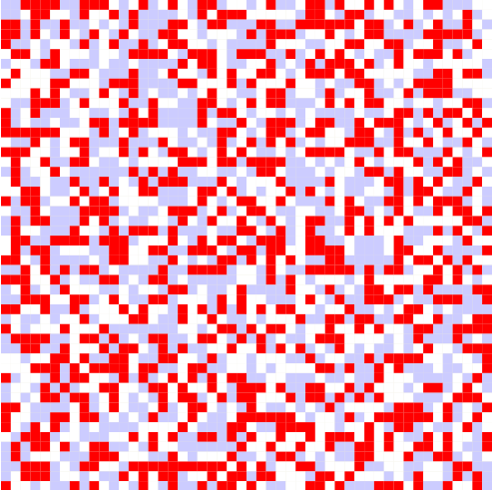 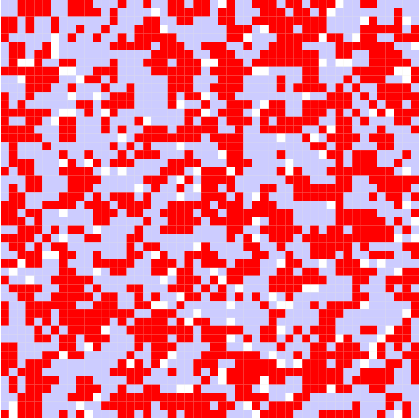 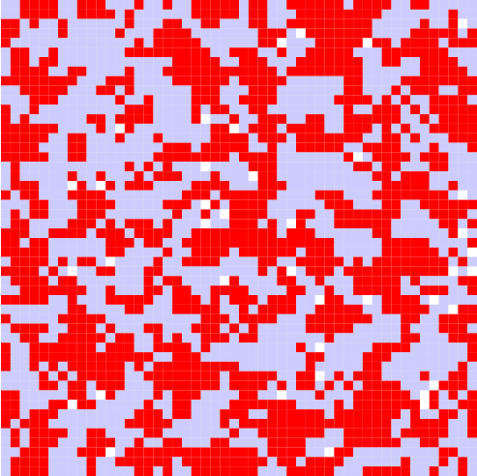…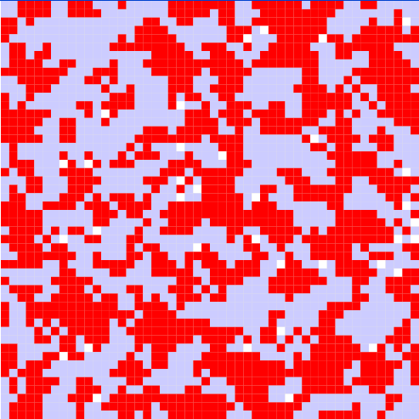

Analysis:
Since all the parameters are common to both systems, consumers make their decisions solely based on the effect of network externality. The result is that most of the non-users become users of one of the two systems, and users using the same products tend to aggregate together to form their own society, which in turn enhances the network externality. The interesting thing is that the remaining white cells have exact four red neighbors and four blue neighbors. This simulates those consumers who are hesitant to make their purchasing decisions when there is a network externality tie.

Case 2: Mature market with different prices
Simulation settings:
U_{min} = 0.4, U_{max} = 0.8, λ = θ = 0.5, P_{OS1} = 0.25, P_{OS2} = 0.3
Simulation scripts and related files:
Mature_DiffPrices.bat, Mature_DiffPrices_DRWLOG.bat, Mature_DiffPrices.ma, Mature_DiffPrices.log, Mature_DiffPrices.drw, matureMarket.VAL, Consumerschoice.pal
Instantiated local computing rules:
Current State | Next State | V(c_{ij}, n, t) | Rule
0 | 1 | 0.2stateCount(1)/9 + 0.15 (a) | ((a)>(b)) AND ((a)>(c))
0 | 2 | 0.2stateCount(2)/9 + 0.1 (b) | ((b)>(a)) AND ((b)>(c))
0 | 0 | 0 (c) | ((c)>(a)) AND ((c)>(b))
1 | 1 | 0.2stateCount(1)/9 + 0.25 (a) | ((a)>(b)) AND ((a)>(c))
1 | 2 | 0.2stateCount(2)/9 + 0.1 (b) | ((b)>(a)) AND ((b)>(c))
1 | 0 | 0 (c) | ((c)>(a)) AND ((c)>(b))
2 | 1 | 0.2stateCount(1)/9 + 0.15 (a) | ((a)>(b)) AND ((a)>(c))
2 | 2 | 0.2stateCount(2)/9 + 0.2 (b) | ((b)>(a)) AND ((b)>(c))
2 | 0 | 0 (c) | ((c)>(a)) AND ((c)>(b))
Simulation Results:
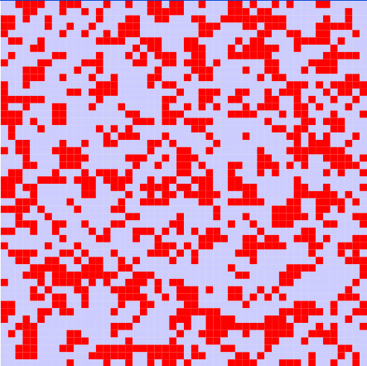…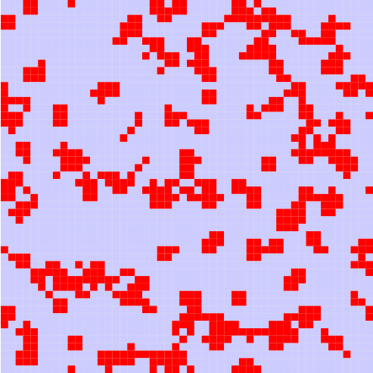…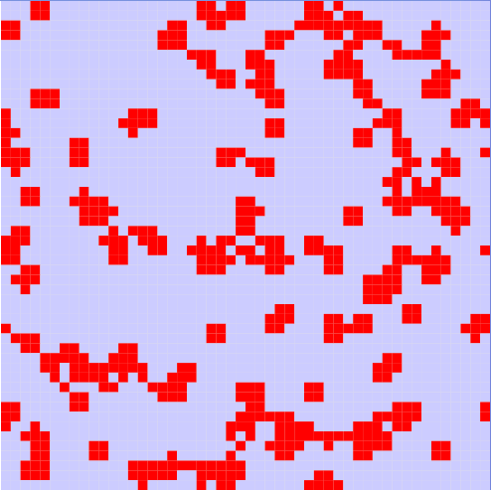

Analysis:
Since the price for OS1 is lower than the price for OS2 and all other parameters are the same, we can observe more non-users choose to use OS1. At the same time, some original users of OS2 shift to OS1 as well. Even though the price difference is small, it still can have a prominent impact on the market. Again, the effect of network externality results in the aggregation of users of the same products. This time, there are no non-users in the simulation. The price difference successfully breaks the network externality ties.

Case 3: Mature market with fluctuant prices
In this case, the global prices for both systems remain constant, yet the local price for each consumer fluctuates according to the consumer’s local market environments (market within the cell’s neighborhood). Both providers will raise their prices for a consumer if they have a larger market share within the consumer’s local market. Otherwise, they will lower their prices for a consumer if their market share lags behind their competitors. We suppose that the global prices and local price bounds are the same for both providers. However, provider2 allows the local price of its product more volatile (μ2 = 1) than procider1 (μ1 = 0.2).
Simulation settings:
U_{min} = 0.4, U_{max} = 0.8, λ = θ = 0.5, Q1 = Q2 = 0.1, R1_{max} = R2_{max} =0.15, R1_{min} = R2_{min} =0.05, μ1 = 0.2, μ2 = 1
Simulation scripts and related files:
Mature_FlucPrices.bat, Mature_FlucPrices_DRWLOG.bat, Mature_FlucPrices.ma, Mature_FlucPrices.log, Mature_FlucPrices.drw, matureMarket.VAL, Consumerschoice.pal
Instantiated local computing rules:
Current State | Next State | V(c_{ij}, n, t) | Rule
0 | 1 | 0.18stateCount(1)/9 + 0.02stateCount(2)/9 + 0.25 (a) | ((a)>(b)) AND ((a)>(c))
0 | 2 | 0.1stateCount(1)/9 + 0.1stateCount(2)/9 + 0.25 (b) | ((b)>(a)) AND ((b)>(c))
0 | 0 | 0 (c) | ((c)>(a)) AND ((c)>(b))
1 | 1 | 0.18stateCount(1)/9 + 0.02stateCount(2)/9 + 0.35 (a) | ((a)>(b)) AND ((a)>(c))
1 | 2 | 0.1stateCount(1)/9 + 0.1stateCount(2)/9 + 0.25 (b) | ((b)>(a)) AND ((b)>(c))
1 | 0 | 0 (c) | ((c)>(a)) AND ((c)>(b))
2 | 1 | 0.18stateCount(1)/9 + 0.02stateCount(2)/9 + 0.25 (a) | ((a)>(b)) AND ((a)>(c))
2 | 2 | 0.1stateCount(1)/9 + 0.1stateCount(2)/9 + 0.35 (b) | ((b)>(a)) AND ((b)>(c))
2 | 0 | 0 (c) | ((c)>(a)) AND ((c)>(b))
Simulation Results:
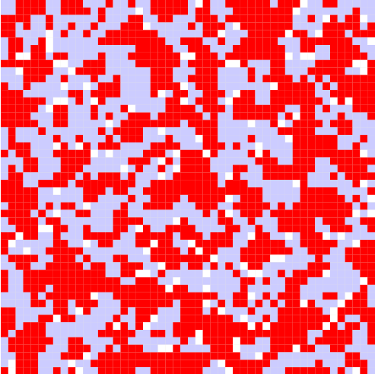…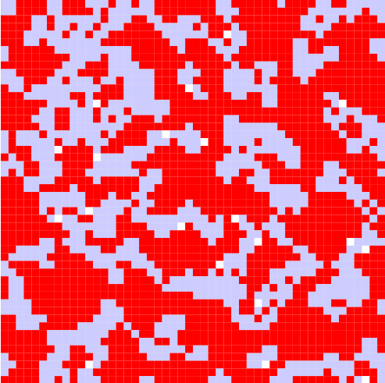…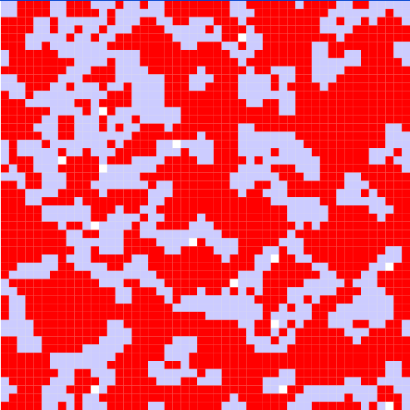

Analysis:
In this case, provider2 has higher pricing flexibility (μ2 = 1), while provider1 is relatively more rigid (μ1 = 0.2). We can observe that provider2 gains bigger market share than provider1 does at the end of the simulation. In addition, when the local market shares for both providers are equal, i.e. for cells that have exact four red neighbors and four blue neighbors, the price fluctuation disappears. A tie happens again. The non-users at the end of the simulation are in this condition. The reason is that the network externality becomes the sole force in determining consumers’ decisions when price fluctuation stops given all other parameters are the same.

New Market Dynamics Simulation Results and Analysis
Case 4: New market with identical prices
In this case, the same settings and rules as in case 1 (Mature market with identical prices) are applied to a cell space representing a new market in order to show the differences between dynamics of a mature market and a new market. The new market is represented as a cell space with a small number of scattered users.
Simulation scripts and related files:
New_SamePrices.bat, New_SamePrices_DRWLOG.bat, New_SamePrices.ma, New_SamePrices.log, New_SamePrices.drw, newMarket.VAL, Consumerschoice.pal
Simulation Results:
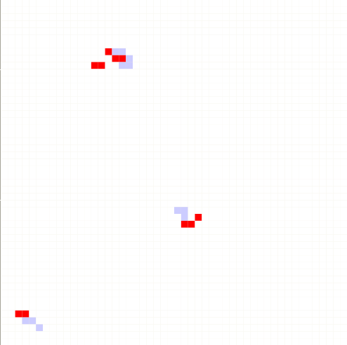…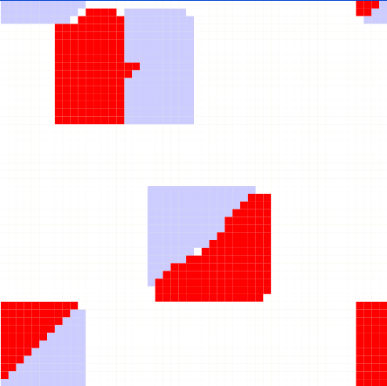……

Analysis:
Since most of consumers are non-users at the beginning and all the parameters for both systems are the same, the development of the new market starts around the few initial users where the network externality takes effect. OS1 users and OS2 users rapidly grow almost at the same rate until the market is saturated. From this simulation, we can see that the initial users have been the pivots of the development of the market. This is the reason why there are many relentless marketing campaigns in exploiting a new market.

Case 5: New market with different prices
In this case, the same settings and rules as in case 2 (Mature market with different prices) are applied to a cell space representing a new market.
Simulation scripts and related files:
New_DiffPrices.bat, New_DiffPrices_DRWLOG.bat, New_DiffPrices.ma, New_DiffPrices.log, New_DiffPrices.drw, newMarket.VAL, Consumerschoice.pal
Simulation Results:
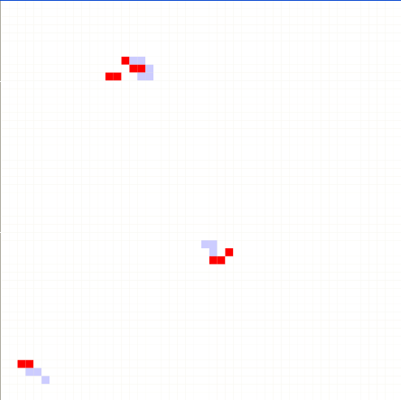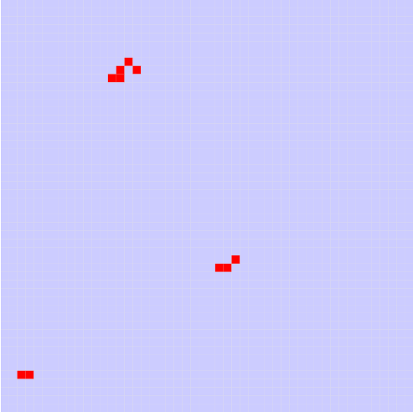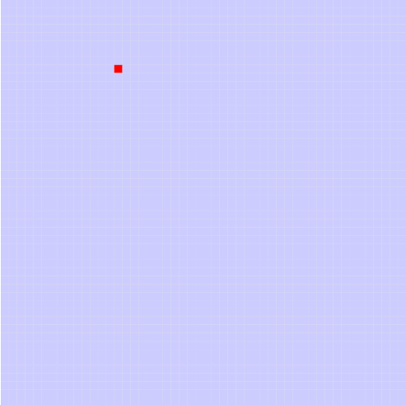

Analysis:
From this simulation, we can see that provider1 rapidly monopolizes the whole market by virtue of its lower prices. The sensitivity of price is much higher in a new market than in a mature market due to the absence of network externality.

Case 6: New market with fluctuant prices
To focus our study on what impact will be exerted on the new market by price fluctuation, we eliminate the global price factor in this case. At the same time, the difference between the minimum and maximum local prices is enlarged to give more flexibility in exploiting the new market. Again, we suppose that the global prices and local price bounds are the same for both providers, while provider2 allows the local price of its product more volatile (μ2 = 1) than procider1 (μ1 = 0.2).
Simulation settings:
U_{min} = 0.4, U_{max} = 0.8, λ = θ = 0.5, Q1 = Q2 = 0, R1_{max} = R2_{max} =0.3, R1_{min} = R2_{min} =0, μ1 = 0.2, μ2 = 1
Simulation scripts and related files:
New_FlucPrices.bat, New_FlucPrices_DRWLOG.bat, New_FlucPrices.ma, New_FlucPrices.log, New_FlucPrices.drw, newMarket.VAL, Consumerschoice.pal
Instantiated local computing rules:
Current State | Next State | V(c_{ij}, n, t) | Rule
0 | 1 | 0.14stateCount(1)/9 + 0.06stateCount(2)/9 + 0.4 (a) | ((a)>(b)) AND ((a)>(c))
0 | 2 | 0.3stateCount(1)/9 - 0.1stateCount(2)/9 + 0.4 (b) | ((b)>(a)) AND ((b)>(c))
0 | 0 | 0 (c) | ((c)>(a)) AND ((c)>(b))
1 | 1 | 0.14stateCount(1)/9 + 0.06stateCount(2)/9 + 0. 5 (a) | ((a)>(b)) AND ((a)>(c))
1 | 2 | 0.3stateCount(1)/9 - 0.1stateCount(2)/9 + 0.4 (b) | ((b)>(a)) AND ((b)>(c))
1 | 0 | 0 (c) | ((c)>(a)) AND ((c)>(b))
2 | 1 | 0.14stateCount(1)/9 + 0.06stateCount(2)/9 + 0.4 (a) | ((a)>(b)) AND ((a)>(c))
2 | 2 | 0.3stateCount(1)/9 - 0.1stateCount(2)/9 + 0.5 (b) | ((b)>(a)) AND ((b)>(c))
2 | 0 | 0 (c) | ((c)>(a)) AND ((c)>(b))
Simulation Results:
………

Analysis:
The dynamics of the distribution of the users of the two systems reflected in this simulation has proven the most interesting. Two types of new users ripple out from the initial ones into alternating circles. The development of the market shows some pattern that cannot be explained by any single factor of the value function.

Notes and References
[1] In this final report, the original conceptual model has been modified as follows:
- Two types of markets have been distinguished and simulated respectively instead of only one market.
- Three sets of rules have been applied to both types of markets.
- The effect of local price fluctuation has been taken into consideration.
- Different parameter values have been tested to study the reaction of the model.

[2] “The Application of Cellular Automata to the Consumer's Theory: Simulating a Duopolistic Market”, Sobei H. Oda1, Kouhei Iyori2, Miura Ken3, and Kanji Ueda4, pp. 454－461, Springer-Verlag Berlin Heidelberg 1999

[3] The model introduced in “The Application of Cellular Automata to the Consumer's Theory: Simulating a Duopolistic Market” is simplified in this simulation. The skill acquisition function L(c_{ij},n, t) only takes into account a cell’s current state instead of its whole state history, and α,β,γ are set to 0.

Appendix
The source code of the Java utility program used to create VAL files for simulating mature markets is listed as follows:
RandomInitValues.java
/**
* @author Liu Qi
* Created on 28-Oct-2004
* To generate a VAL file containing initial cell values for an r*c cell space. Each cell may have value from 0 to max_StateVal.
* All these integer values are produced with approximately equal probability.
*/
import java.util.*;
import java.io.*;
public class RandomInitValues {
public static void main(String[] args) {
if((args.length == 0) || (args[0].equalsIgnoreCase("-?")) || (args[0].equalsIgnoreCase("-h")) ){
System.out.println("Please input parameters you want to use!");
System.out.println("Usage: java RandomInitValues val_filename max_StateVal rows cols");
System.out.println("val_filename : the VAL file to which you want to save initial cell state values;");
System.out.println("max_StateVal : the maximum possible state value for a cell, the minimal possible state value is always 0!");
System.out.println("rows : the number of rows for the cell space;");
System.out.println("cols : the number of columns for the cell space;");
System.out.println("Type -? or -h to show this message.");
System.exit(0);
}
PrintWriter w = null;
try{
String filename = args[0];
int value = Integer.parseInt(args[1])+1;
int rows = Integer.parseInt(args[2]);
int cols = Integer.parseInt(args[3]);
long time = System.currentTimeMillis();
String line = new String();
Random ran = new Random();
w = new PrintWriter(new BufferedWriter(new FileWriter(filename, true)), true);
for (int r = 0; r < rows; r++){//row index
for(int c = 0; c < cols; c++){ //col index
line = "(" + r + "," + c + ") = " + ran.nextInt(value);
w.println(line);
}
}
time = (System.currentTimeMillis() - time)/1000;
System.out.println(filename + " is created in " + time + " seconds.");
}catch(IOException ioe){
System.out.println("IO Exception!");
}catch(Exception e){
System.out.println("Exception!");
e.printStackTrace();
}finally{
if(w != null){
w.close();
}
}
}
}

To run this program:
java RandomInitValues val_filename max_StateVal rows cols
To read the help information of this program:
java RandomInitValues -? | -h

